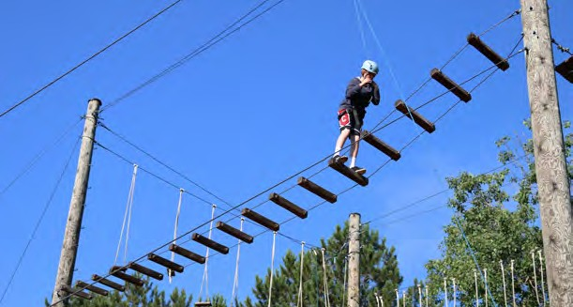
Sport /Activity Equipment & Clothing List

Adventure Climbing
Extra pair of shoes (strong closed toe footwear required), wind pants and jacket, water bottle (500-1000 ml).

All Sports/ Adventure
3 sets of practice clothing (shorts, T-shirts, socks, etc.), 1 or 2 pair of running shoes.

Aqua Sports
2 or 3 bathing suits, shorts and shirts, towels, hat, sandals that stay on feet (no flip flops).

OPTIONAL: Life jacket (labeled with your name).

Archery
Comfortable clothing and appropriate footwear. OPTIONAL: Your own archery equipment

Athletic Conditioning
- sets of practice clothing (shorts, T-shirts, socks, etc.), 1 or 2 pair of running shoes.

Badminton
3 sets of practice clothing (shorts, T-shirts, socks, etc.), your own racquet (labeled with your name).

Baseball
3 sets of practice clothing (i.e., shorts, T-shirts, socks, etc.) baseball glove and baseball cap, sweatpants for sliding drills, protective cup.
OPTIONAL: molded sole shoes, uniform.

Ball Hockey

2 hockey sticks, hockey helmet with cage, hockey gloves, running shoes.

Basketball
3 sets of practice clothing (i.e., shorts, T-shirts, socks, etc.) 1 or 2 pair of basketball shoes.
OPTIONAL: mouth guard.

Boxing
3 sets of practice clothing (i.e., shorts, T-shirts, socks, etc.), sweat suit, jogging shoes (high cut gym shoes if possible) RUN 15 MINUTES A DAY 1 MONTH PRIOR TO CAMP.

Canoe/Kayak
- swimsuits
OPTIONAL: Personal canoe paddle
wet suit, life jacket (labeled with your name).

Cheer Camp
- sets of practice clothing (i.e., shorts, T-shirts, socks, etc.). OPTIONAL: Uniform, pom-poms.

Competitive Swim
- or 3 bathing suits, cap, goggles, sweatsuit(s), towels.
Creative Arts
OPTIONAL: Sketchbook

Cross Country
2-3 pair of shorts, lots of short and long sleeve shirts and socks, bathing suit, 2 pair of runners.
OPTIONAL: Racing flats or spikes

Dance
Appropriate dance clothing and footwear required, 3 sets of dance pants, crop tops, leotards, unitards, tights (with and without feet), for performance, one outfit in black is required.
OPTIONAL: Tap shoes or hard soled shoes, ballet
slippers (soft slippers preferred), jazz oxfords, boots, all shoes acceptable. Campers should have their hair in a bun or tied back off their face.

Dodgeball
- sets of practice clothing (shorts, T-shirts, socks, etc.), 1 or 2 pair of running shoes.

Fishing
Fishing rod, reel, tackle box and lures, rubber boots, rain gear, long pants, shoes for hiking, bug spray, hat.

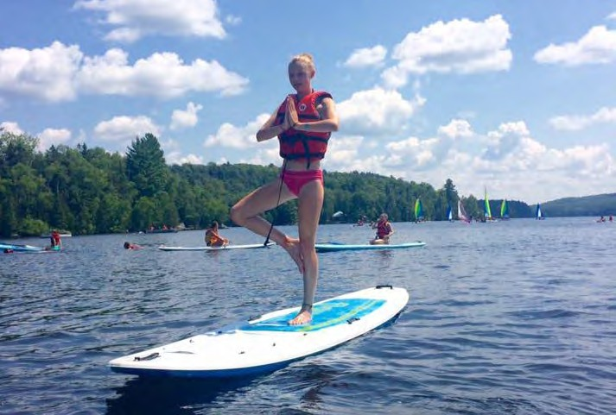

Flag / Touch Football
2-3 shorts, 2-3 t-shirts, running shoes.
OPTIONAL: Running shoes with non-metal spikes.

Football
Campers must supply their own equipment which should include: regulation and N.O.C.S.A.E. approved helmet, molded mouth guard, chin straps, shoulder pads, kidney pads, pants with thigh pads, athletic supporter, multi-cleated (molded sole) shoes.

Glee/Theatre Camp
OPTIONAL: Costumes

Gymnastics

2 or 3 sets of leotards or body suits.

Judo and Karate
2-3 sets of practice clothing, 2 Gi outfits (if possible), towels

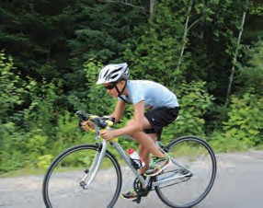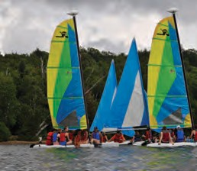

Outdoor Skills & Adventure
Hiking boots, wool blend socks (3-4 pr.), long sleeve shirts, cotton T-shirts, shorts, hat, rain suit, sweatshirt/fleece, compact sleeping bag, closed cell foam sleeping pad, water bottle (500-1000 ml), personal cup, bowl and utensil set (knife, fork, spoon).
Backpack (min. 55 litres) with padded hip belt, shoulder straps.

Power Up for School & Life Success
Binder, pen, lined paper

Quarterback and Receiver Camp

Helmet, molded mouth guard, shoulder pads, molded sole shoes, athletic supporters, shorts, socks, T-shirts, sweat suit.

Quest for Adventure
Extra pair of shoes (strong closed toe footwear required), wind pants and jacket, water bottle (500-1000 ml).

Rugby
1 or 2 rugby jerseys, mouth guard, 2 or 3 pairs of practice equipment (shorts, T-shirts, socks), jock strap, mouth guard. OPTIONAL: athletic supporter, rubber cleats (soccer boots).

Sailing

1 or 3 bathing suits, shorts and shirts, towels, hat, sandals that stay on your feet (no flip flops).
OPTIONAL: life jacket (labeled with your name).

Self-defense
Long track pants (sweats) 2 sets, 4-5 T-shirts, regular running shoes

Seven Habits
Binder, lined paper and pen, in addition to general packing list.

Soccer
Shin guards are mandatory in Ontario Soccer, 3 sets of practice clothing (shorts, T-shirts, socks, etc.)
Strongly recommended: molded sole shoes.

Stand Up Paddle Board
2 or 3 bathing suits, shorts and shirts, towels, hat. OPTIONAL: wet suit, life jacket (labeled with your name).

The SportsLab Performance Program

2 sets of practice clothing (shorts, T-shirts, socks, etc.), 1 or 2 pair of running shoes.

Survival Camp
Must have items.
- Rain gear (Coat, pants preferred but not required)
- lightweight water bottle 1L+ (lots of options but a budget option is as simple as a SmartWater bottle 1L)
- compressible sleeping bag
- Sweater/warm clothes for nights
- Flashlight/Headlamp
- Hiking boots (preferably with waterproof treatment) and socks
- Sunglasses
- Sunscreen and bug spray
Extra optional items not required.
- Hiking backpack (Preferably 30-60L)
- Hiking pole
- Nut free granola bars/snacks
- Compact air sleeping pad
- Whistle
- Camera
- Compact camping pillow (preferably blow up)
- Compact microfiber towel
- Camping cutlery (Provided by the camp if not brought)
- Small dry sacks (Mountain warehouse has 10L dry sacks for $10 for cheap options)

Tennis
3 sets of practice clothing (shorts, T-shirts, socks, etc.), tennis racquet, shoes.
OPTIONAL: tennis balls.

Track & Field
Running shoes, 3 sets of practice clothes optional: spikes. Spandex

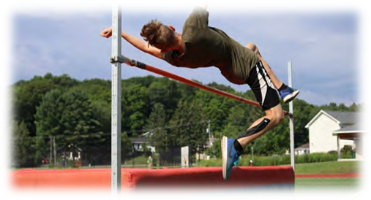

Triathlon
Swim: bathing suit (s), brightly coloured bathing cap, beach towel(s).
OPTIONAL: swim goggles & cap.
Bike: bicycle, CSA or ANSI approved helmet, 2 extra tire tubes and repair kit, lock and two keys, Allan keys, adjustable wrench and screwdriver, shorts and T-shirts.
Run: running shoes

Tri-sports
3 sets of practice clothing (shorts, T-shirts, socks), l or 2 pair of shoes for basketball and volleyball.
OPTIONAL: molded sole shoes (soccer/baseball).

Ultimate Frisbee
2 or 3 sets of practice clothing (shorts, t-shirts, socks, etc.), running shoes.
OPTIONAL: cleated footwear.

Volleyball
3 sets of practice clothing (shorts, T-shirts, socks, shoes, etc.), shoes for volleyball.

Wrestling
3 sets of practice clothing (shorts, T-shirts, socks, etc.), wrestling singlet (preferred, but not essential).

