**OLYMPIA SUMMER 2023**

**GET READY FOR CAMP PACKAGE**

**PRIOR to ARRIVAL at CAMP:**

For the betterment of Camper and Staff health, we ask that all Campers and Staff self-screen for covid or any other contagions prior to their arrival to camp if they are showing any symptoms.

Proof of Vaccination is not required to be uploaded to your account. Campers will not be tested upon arrival to camp.

**CABIN ASSIGNMENTS:**

We understand the importance of cabin requests and every effort is made to honor these requests; however, this is not always possible.

Any changes to cabin assignments may be requested by email (sherri@olympiasportscamp.com) up to three weeks prior to your arrival. Switches are not guaranteed and will depend on space and availability. Changes cannot be made during check-in or during your child’s stay.

**ARRIVAL TIME: 12-2 PM**

If you arrive early before check-in time has started, you may park alongside the road and wait until registration opens.

If you are unable to arrive during the check-in window, please contact our office to schedule an alternate arrival time. All requests must be made in writing to [info@olympiasportscamp.com](mailto:info@olympiasportscamp.com)

**WHILE at CAMP:**

Staff will be performing and promoting frequent, proper hand hygiene (including supervising or assisting camp participants with hand hygiene). Handwashing using soap and water is recommended over alcohol-based hand rub (ABHR) when visibly soiled.

Staff and campers will follow a routine of hand washing with soap and water throughout the day. For example: Washing hands before we arrive to session, after using the washroom, before and after eating, after playing outdoors, after using a tissue, and any time hands are visibly soiled.

Hand sanitizing stations will be available throughout camp sites.

Masks may be worn indoors at a camper’s discretion or when and where the medical team feel it is in the safety of all to do so.

Campers will be provided a personal storage space/area for their personal belongings. Personal belongings brought to camp should not be shared between individuals. If brought to camp,

personal items (e.g., backpack, clothing, towel, water bottle, food, sunscreen, bug repellent, etc.) should be labeled and kept in the individual’s designated area. Campers have a small storage space under each bunk bed. The space is just under 2 feet high, so please pack your camper’s belongings accordingly.

**DEPARTURE FROM CAMP:**

Closing Ceremonies begins promptly at 11 AM. (Parent(s)/Guardian(s) are welcome to attend)

All campers must be picked-up and of the property before noon.

If you need to pick-up your camper at a different time, (outside of the check-out window) alternative arrangements can be made by submitting a written request to the office: [info@olympiasportscamp.com](mailto:info@olympiasportscamp.com)

If someone other than a child’s parents will be picking them up, a request for an Alternate Driver must be submitted in writing to the office at [info@olympiasportscamp.com](mailto:info@olympiasportscamp.com) . Campers will only be released to those approved on their camper profile.

Campers that are staying with us for more than 1 consecutive week will remain on the property once check-out is complete. They will have a fully supervised stay-over program with activities including waterfront time, games and movies.

# **How to Reach Us**

The summer office will be open and operating beginning Monday June 27th 9am – 5 pm.

Registrar: [sherri@olympiasportscamp.com](mailto:sherri@olympiasportscamp.com) 905-479-9388

If parents must reach their camper, a message may be left with the camp office staff during office hours. Messages will be delivered to the child's counsellor.

Messages left after office hours will be monitored and, unless it is an emergency, calls will be returned the next morning during business hours.

**Driving Directions**

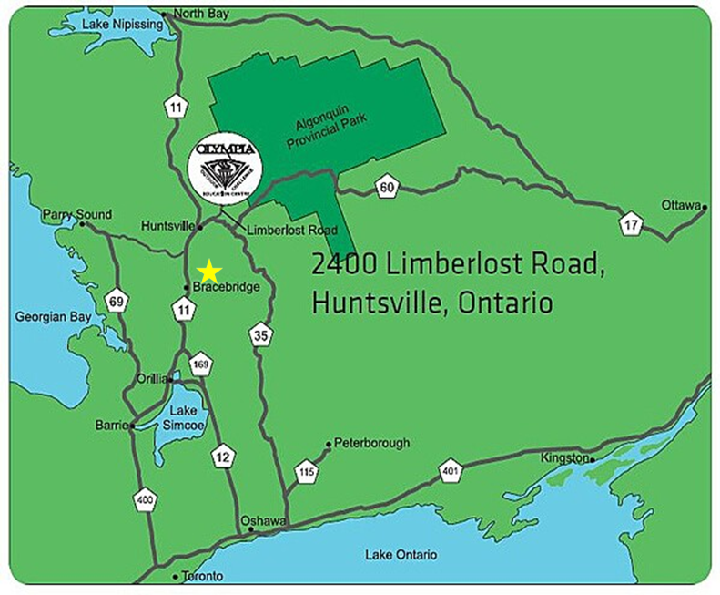

**From Toronto and West GTA:**

Take Highway 400 north to Barrie. Continue north on Highway 11 to Huntsville. Exit at Highway 60 toward Ottawa. Continue east until Limberlost Road.

Turn left and travel north for 14 km. The camp entrance will be on your right.

**From Toronto and East GTA:**

Take 401 east to Hwy 35/115. Travel north and exit at Highway 35 and continue

north to Highway 60. Turn west onto Highway 60. Continue west until Limberlost Road. Turn right and travel north for 14 km. The camp entrance will be on your right.

**From Ottawa:**

Take Highway 417 west and continue west onto Highway 17. Merge onto Highway 60 and continue west until Limberlost Road. Turn right and travel north for 14 km. The camp entrance will be on your right.

**General Packing List**

**Label your child’s belongings!**

sleeping bag or sheets/fitted sheet and blankets (mattresses are singles) pillow

bath towel, face cloth, toiletry items (soap, toothpaste, etc.), beach towel

sunscreen, insect repellent/ bug spray

shorts, track pants, jeans

undergarments, pyjamas, socks (sport and cozy)

sweatshirts, cotton shirts, sweaters

one or two bathing suits, workout wear,

jacket, raincoat, hats and/or crazy hats, sunglasses

shoes (2 pairs), and rain boots or extra shoes

postage stamps and writing paper, pen, notebook, books to read (for downtime)

reusable water bottle, flashlight with batteries

Please Note: For those attending during the last two weeks in August:

bring warmer clothing as the evenings tend to cool off.

**For Your Sport Specific Packing List Please see Attached**

**How to send your camper mail**

Mail can be sent to campers during their stay to our Huntsville address. To help us ensure proper delivery, please have your camper's name clear and visible on the envelope.

Please make sure to also include a return address.

Please be advised: POSTAL SERVICE IS EXTREMELY SLOW!

RR#4, 2400 Limberlost Road

Huntsville, Ontario Canada P1H 2J6





**Camper Expectations**

Parents and campers alike wish to have the best camping experience possible. To ensure this, we reserve the right to dismiss a camper if it is in the best interest of the camper and/or the camp. There will be no refund of any kind should a camper be dismissed for infractions or behaviour that is deemed inappropriate by Olympia Sports Camp staff and its directors.

-There are to be no boys in girls’ cabins and no girls in boys’ cabins at any time. Any infractions of this rule will result in immediate dismissal.

-Bullying will not be tolerated and will result in immediate dismissal.

-Theft will result in immediate dismissal.

-There is to be no use of waterfront facilities unless Olympia staff is on duty and present.

-Campers are to attend all sessions, unless excused by Health Centre Staff.

-Campers are expected to use appropriate language with fellow campers, staff, coaches, and referees always.

-Campers are to respect camp property. Any damage to cabins, camp property or camp facilities will result in the camper being financially responsible for the damages and the cost of repairs.

-Campers are to always remain on camp property.

-Campers are expected to return to their cabins directly following evening program. Once in their cabins, they are not to leave for the night.

**Friendly Reminders**

**Do Not Send Your Child to Camp if they are feeling unwell, showing symptoms, or testing positive for Covid 19.**

Notify the Camp and arrange for another Summer 2023 Camp week based upon availability or a full credit for all monies paid toward Summer 2024.

Cancellations for medical reasons must supply a doctor’s note dated before your child’s session(s) start date. You will receive full credit for all monies paid to be carried forward for 1 summer.

If your child is sent home by our medical staff after their session has started, you will have two options: A credit for the value of the unused days to be carried forward for 1 summer. (This will be pro-rated per day) **OR** A refund for half the value of the unused days.

**What Not to Bring**

We understand the importance to be in contact with your child while they are away from home. Olympia’s top priority is fostering a safe and nurturing environment and we understand that putting your child in our care is an act of trust which we take very seriously.

Our goal is to have every camper fully present and engaged with each other, our staff and coaches during their stay. We ask that cell phones and other electronic devices NOT be brought to camp. If a camper is found with any of the below listed devices, it will be locked away. NO EXCEPTIONS. Items will be returned upon the camper’s departure.

OLYMPIA WILL NOT BE HELD RESPONSIBLE FOR LOST OR STOLEN ITEMS. DO NOT BRING THEM!

x Cell Phones x MP3 Players x Laptops

x Gaming Devices x iPods and iPads

The following are also NOT Permitted at camp:

x Tobacco x Alcohol  x Fireworks xVapes

x Weapons of Any Kind x Drugs or Drug Paraphernalia

POSSESSION OF ANY OF THESE ITEMS WILL RESULT IN IMMEDIATE DISMISSAL FROM CAMP.

**OLYMPIA IS A NUT AWARE CAMP**

We are a Nut Aware camp and as such we strive for a nut-free environment to ensure the safety of our campers and staff with severe nut allergies. We ask that you help us maintain this environment by not bringing nut products to camp. If any products are found, they will be confiscated and destroyed immediately.

**The Tuck and Pro Shop**

The Tuck Shop is our camp store which sells a variety of different products for purchase.

Each camper has their own account with a pre-paid amount that has been set up by the camper’s family. Each time your camper makes a purchase, the amount will be deducted directly from the account.

At the end of your child’s stay, any unused funds remaining in the account over $5.00 will be refunded back onto the card that was originally used to set up the account. No money will be returned to the camper.

We ask that you complete the account set-up BEFORE your child’s arrival.

The following list will give you an idea of the items available in the Tuck and Pro Shop.

* O.S.C. Hoodies ($45.00)
* Shorts & T-shirts ($20.00)
* Sweatpants ($50.00)
* Hats ($25.00-$35.00)
* Bracelets & Headbands ($5.00-$10.00)
* Jerseys ($35.00)
* Coca-Cola beverages ($2.50+)
* Chips ($2.50-$5.00)
* Candy ($2.00+)
* Chocolate bars ($2.00+)
* Ice Cream & popsicles ($2.00+)

*All items are subject to HST. **Prices may vary and are subject to change

Laundry service is available to campers that are staying for more than 1 consecutive week.

The cost is $18.00 PER CAMPER, PER LOAD which includes 2 washes: 1 light and 1 dark. Payment for this service will be deducted from your child’s Tuck account. Please consider this cost when setting up your Tuck account.

Tuck Shop will have a BBQ lunch for purchase on Sunday during the drop off period (12-1:30).

**Pre-Arrival Check List**

All camp fees must be paid in full BEFORE arriving at camp. The account must be settled before check-in.

Set-up Your Tuck Account.

Review the Cancellation Policy and its Important Dates.

Keep up to date with modifications and adjustments through our website and our email communications.

Reserve Your Seat on the Bus